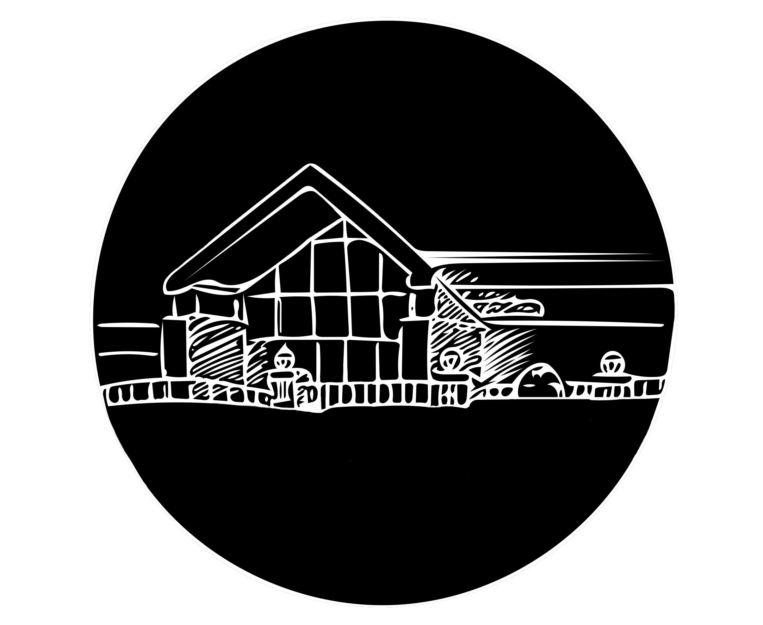

Creative Arts
Production Ministry Team Member Job Description and Policies
(2018 - 2019)

Statement of Ministry

Production can be one of the most powerful ministries in the modern church today. We have a great opportunity to assist the spiritual side of ministry that happens on campus with our talents and commitments.

As a ministry we have a responsibility to the college to work as we would anywhere else. We must do what we is asked of us, follow the chain of command, and do our best. As a ministry, we must take things a step further. We must remember these simple ideas:

1. Everything we do, we do it for the glory of God
2. Distractions can bring focus away from the work of God
3. Every time we lose focus, we risk creating a distraction
4. God is honored in our work ONLY when we work in the right spirit
5. Media production is a job of servant hood
6. We must also adhere to the The GCLT Covenant:

We are a team that (in our personal and common life) …

Practices worship (life under the Lordship of Jesus Christ),
Practices prayer,
Practices listening to the Word,
Practices discernment,
Practices grace-filled relationships (integrity),
Practices the Missio Dei,
Practices healthy, team processes
…be prompt
…be prepared (practice/memorization of music)
…be patient
…be creative
…be a learner
…be servants of one another

Description and Policies

Being a part of the Production Ministries Team (PMT) is a privilege. While sound, lighting, and media are effective tools in ministry, if used incorrectly they will draw focus away from the Lord and onto our surroundings. It is in our charge that while the student body, faculty/staff, and members of our community attend events we are apart of, we attempt to eliminate as many distractions as possible. To help this process, here are the policies for the Production Team:

1. To operate sound, lighting and media equipment for a specific ministry that has a need.

2. To set up and tear down equipment for the ministry events as required.

3. To maintain storage, upkeep, and organization of Grace Chapel equipment.

4. To participate in training sessions given by the DCA.

5. To communicate any problems with equipment to the DCA.

6. To appropriately facilitate production needs throughout Toccoa Falls College Campus.

7. To help create a Spirit filled atmosphere in Grace Chapel.

8. Be present at all Grace Chapel events.

9. Assist with a servanthood attitude.

10. No one outside of the PMT will operate sound equipment.

11. No activities other than assigned duties are permitted during any event.
(ex. homework, reading, internet, etc)

12. Attention must be given to any leader or speaker during all events.

13. All assigned duties must be completed on schedule.

14. Work when scheduled; PMT Members are only excused from a scheduled work detail when first approved by the DCA and the shift is sufficiently covered.

15. Be early to every event in which you are scheduled.

16. Appropriate dress is required at all times.

17. Once an event is underway; do not leave your assigned duty area.

18. All equipment is to be used for official business. Personal use of any equipment without special arrangement with the DCA is strictly prohibited.

19. No food or drinks are permitted near any sound equipment.

20. Be polite and helpful to everyone. (speakers, faculty/staff, student groups, etc).

21. If there is any problem, follow the chain of command: PMT Members report problems directly to the Director of Creative Arts, who reports to the Director of Spiritual Formation.

22. Always put away and lock up any equipment used immediately after all events unless otherwise instructed.

23. No use on cell phones unless otherwise instructed.

24. Failure to show up at scheduled event will result in termination.

25. Tardiness will not be tolerated and will result in a write up.

I, , have read and understand all the above policies and description and agree to follow them. I also understand that violation of any or all of these policies is grounds for dismissal from the Production Team and will revoke all privileges I have received. I will subject myself to the authority set above my by Toccoa Falls College and the Creative Arts Department.

PMT Signature: _______________________ Date:_________________

